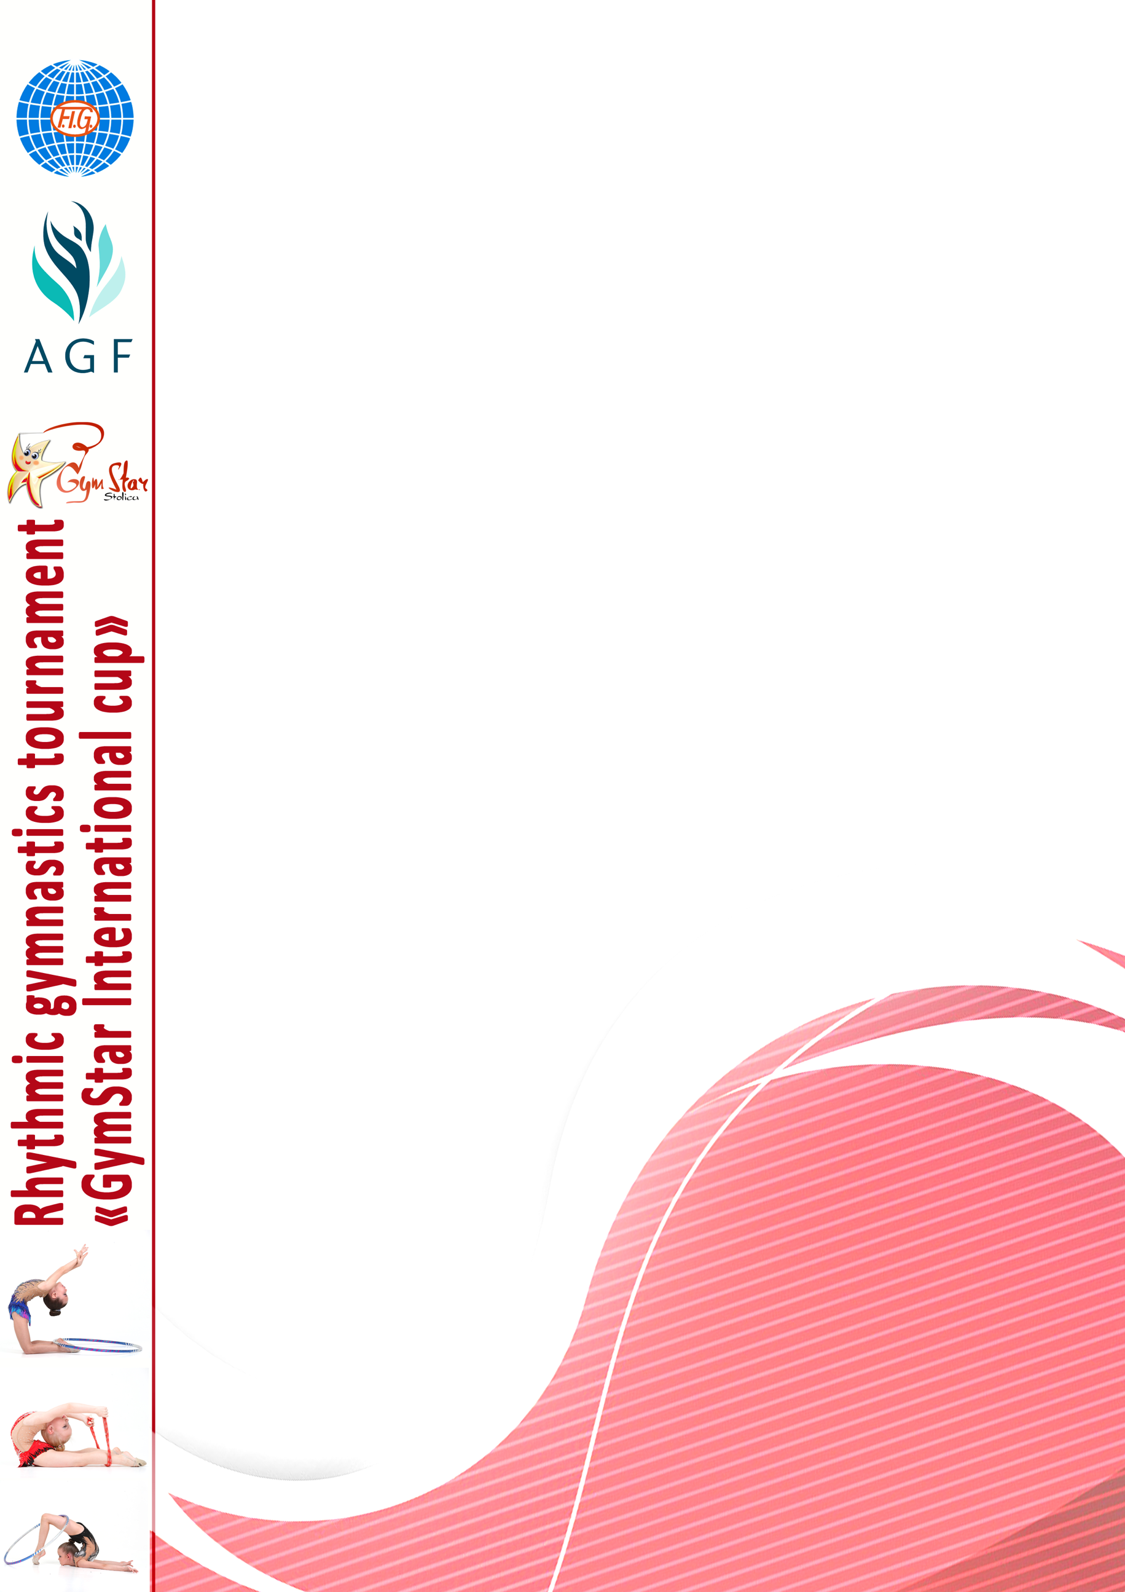
«GymStar Stolica» Rhythmic Gymnastics Sports Club
is pleased to invite you to the 1st GymStar International Cup,
RG worldwide championship held in Baku on March 22-25th, 2018.

Official Programme

Discipline | Rhythmic Gymnastics (RG)
Organizing committee | «GymStar Stolica» international rhythmic gymnastics club  Tel: +994502502943  Tel: +79035323347  E-mail: gymstarinternationalcup@yandex.ru
Location | Baku, Azerbaijan
Dates & Schedule | March 22 – arrival  March 23 – test training, judges meeting  March 24 – competitions  March 25 - departure
Delegations | Unlimited number of participants  All delegations must travel with 1 Team Coach and 1 Judge  A penalty of 80 € will apply to teams for not providing a judge  * Penalty will not apply for individual gymnasts traveling alone with parents
Regestration Deadlines | All applications must be sent by 1.03.2018  Preliminary applications must be sent by 23.02.2018  gymstarinternationalcup@yandex.ru
Accommodation | Smith Hotel Baku: single – 70$, double – 80$, breakfast included, extra bad can be provided, if needed. Address: 22 Koroglu street.  Askar Hotel Baku: double – 93$, triple – 116$, quadruple – 138$. Extra bad can be provided, if needed, breakfast included. Address: 121E Fatali khan Khoyski Avenue
Entry fees | 40euro each gymnast, 60euro each group
Music | Musical compositions must be recorded on CD
Awards | Athletes will be awarded within each category by age division. Awards will be given to top 6 places in each event and all-around competition.  1st place - cups, medals and diplomas  2nd-3rd places - medals and diplomas  4th-6th places – medals and diplomas  Participation gifts and certificates will be awarded to all levels.  Special awards will be presented.
Photo & Video | Professional photographer will be working during whole event
Insurance & Medical Servises | Professional medical services will be provided as needed. Delegations are responsible for their members having a valid insurance coverage against accidents, illness and other travel risks. Organisers are not responsible for any liability in case of accident.
Airport Transfer | Included. After buying tickets confirmation with flight number must be sent to our email.
Local Contacts | +994502502943/ +79035323347 - Alexandra
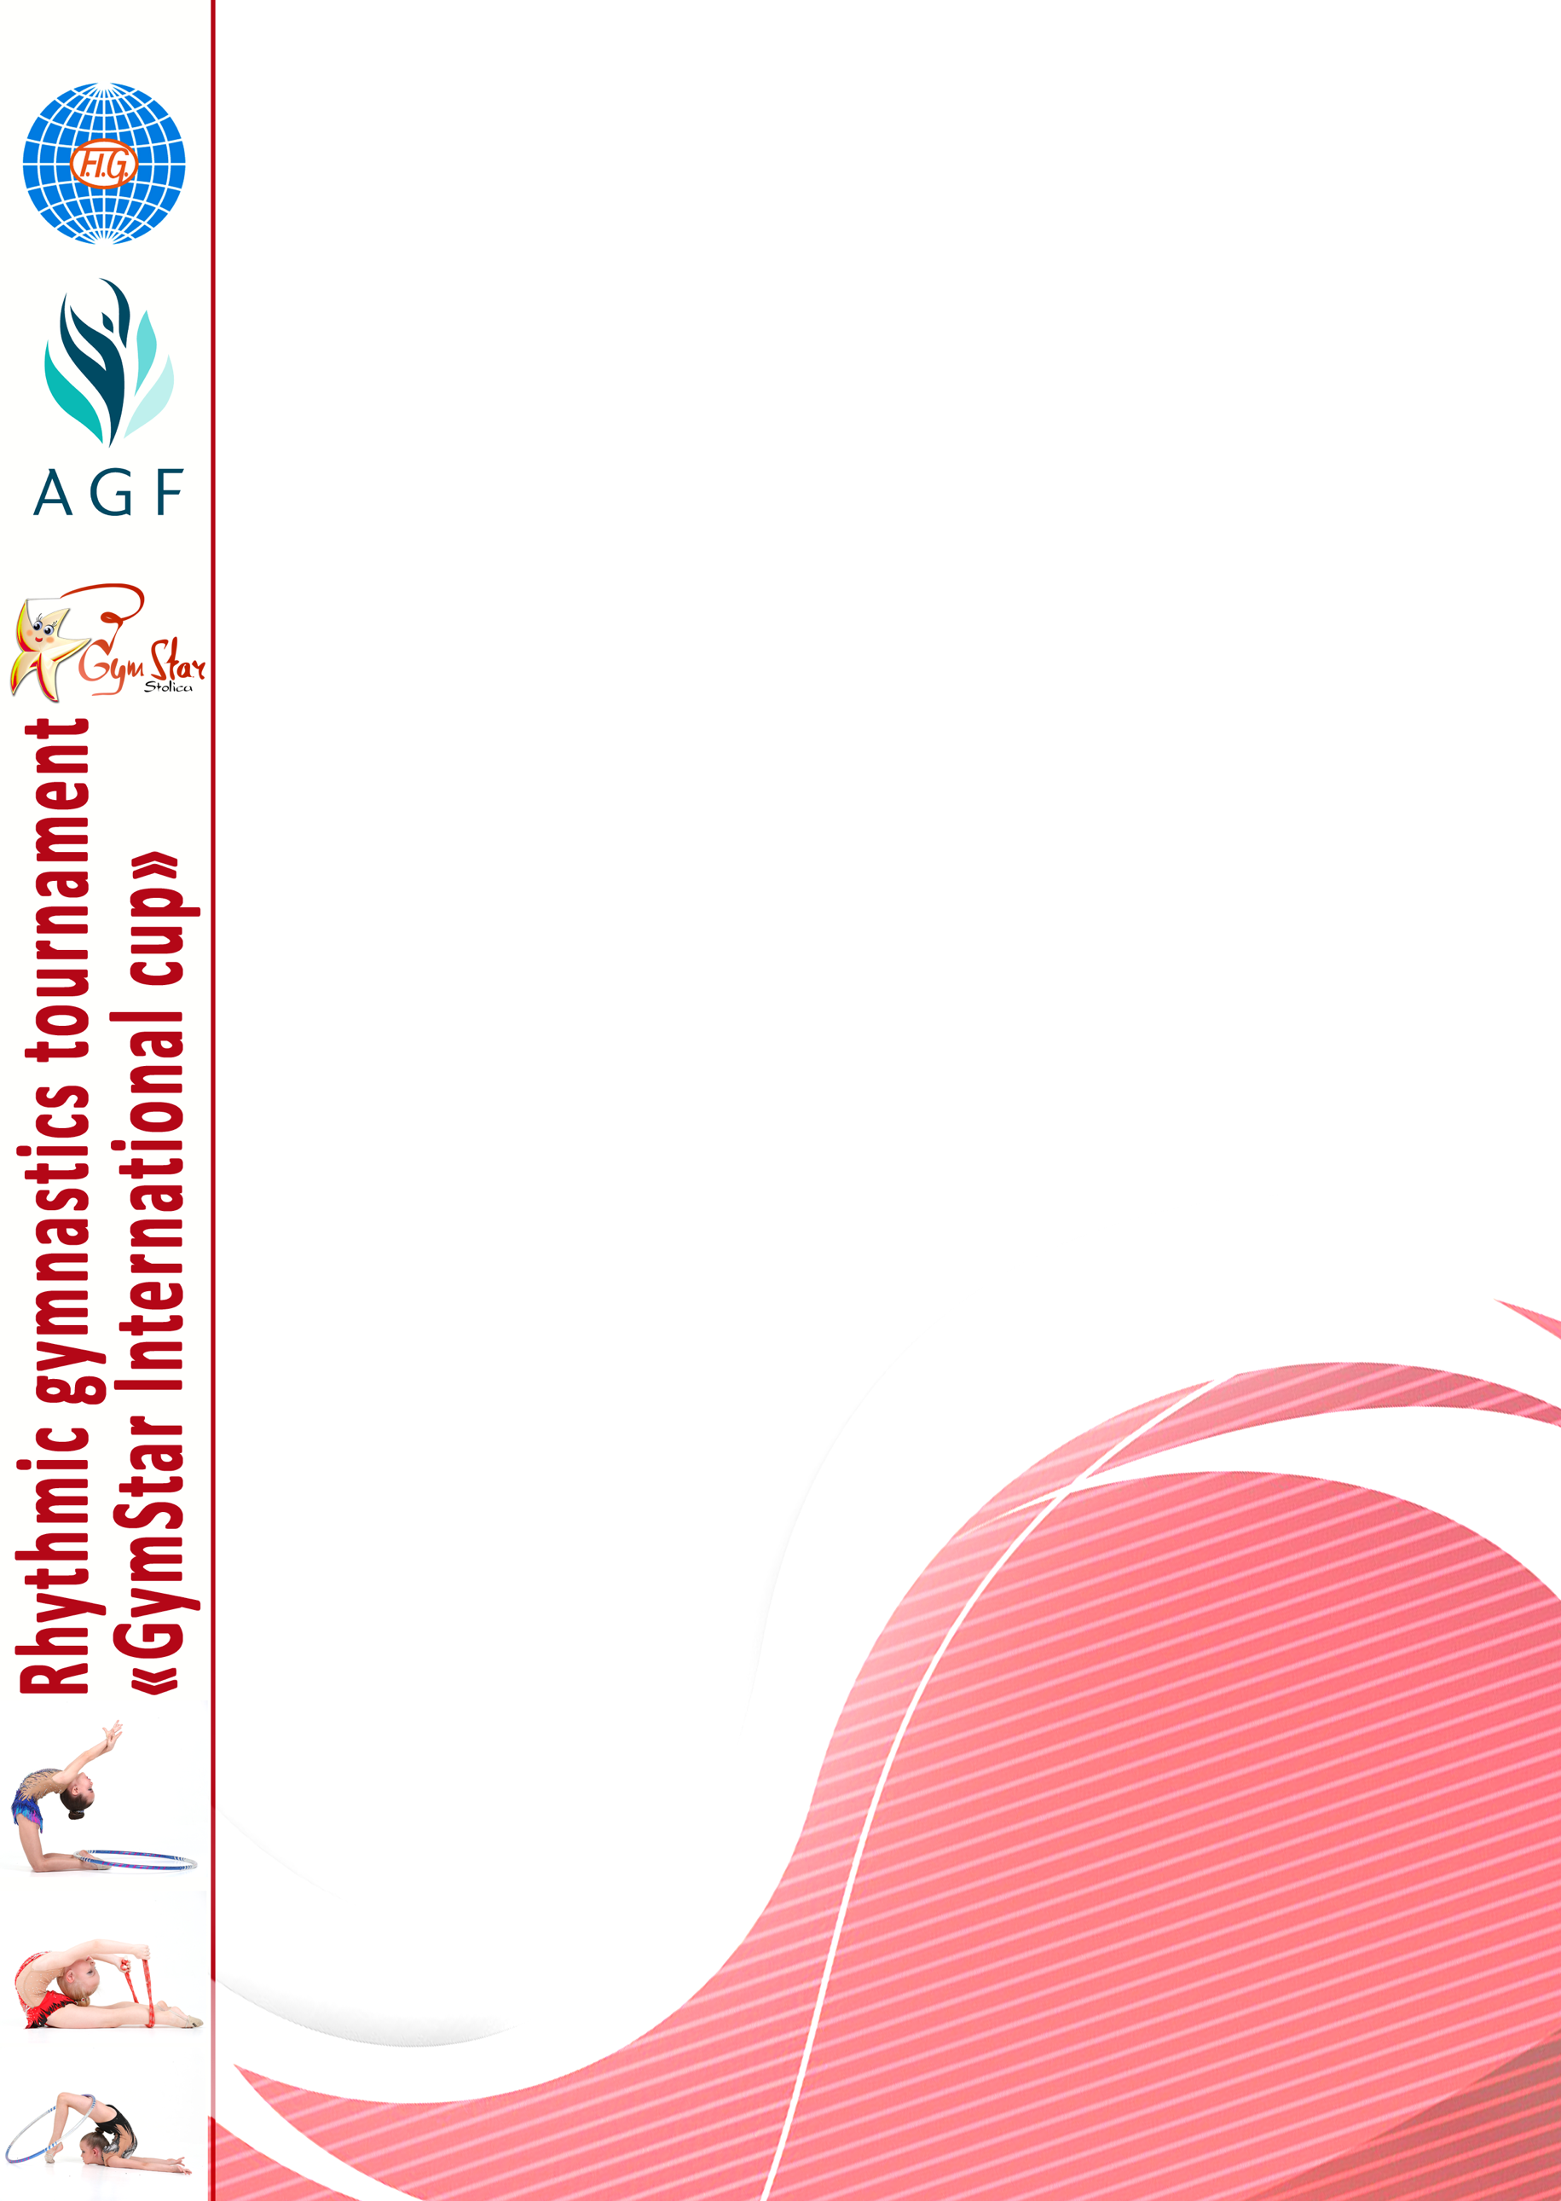  Payment & Bank Account Information | Each participating delegation is kindly requested to make a payment of all fees to the account below by March 1, 2018. In case of a failure to make the payment in due time, the organising committee reserves the right to annul the registration. All payments must be made in Euro currencie.  Bank: Sberbank, Russia  Account number: 40817810338116309288  Contact us for more information
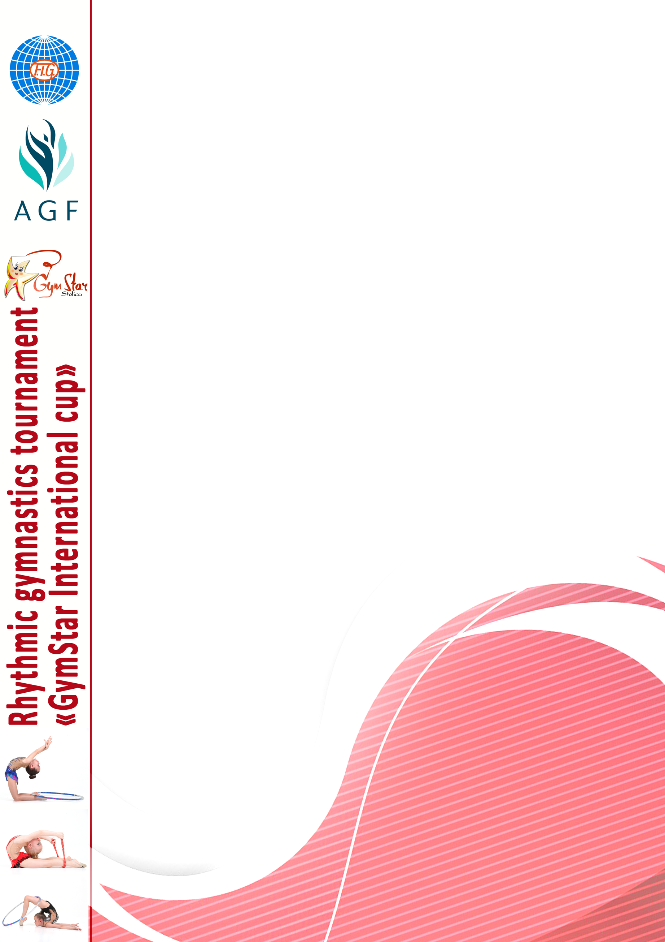

Technical programme – individual excercises
А Category | В Category | С Category | D Category
2013 and younger
(max 5 diff) W.A.
2012 (9 diff)  W.A. | 2012 (max 7 diff)  W.A. D<0,4 | 2012 max (7 diff) W.A. D <0,3
2011 (9+7 diff)  W.A. + 1 app. by choice | 2011 (9 diff)  W.A.D<0,5 | 2011 (max7 diff)  W.A. D<0,3
2010 (9+7 diff)  W.A. + 1 app. by choice | 2010 (7 diff)  1 app. by choice D<0,5 | 2010 (9 diff)  W.A. D<0,4 | 2010 (max. 7 diff)  W.A. D<0,3
2009 (9+7 diff)  W.A. + 1 app. by choice | 2009 (7 diff)  1 app. by choice D<0,5 | 2009 (9 diff)  W.A. D<0,5 | 2009 (max. 7diff)  W.A. D<0,3
2008 г.р. (7+7 diff) 2 apps  by choice | 2008 (9+7 diff)  W.A. + 1 app. by choice | 2008 (9 diff)  W.A. D<0,4
2007  2 app. by choice | 2007 (9+7 diff)  W.A. + 1 app. by choice D<0,5 | 2007 (9 diff)  W.A. D<0,4
2006  2 app. by choice | 2006  W.A. + 1 app. by choice  D<0,4
2005  2 app. by choice | 2005  app. by choice D<0,4
2004-2002
2 app. by choice

2008 - 2009 | W.A.
2009 – 2010 г.р. | W.A
2010 – 2011 г.р. | W.A.

Technical programme – group excersises

№ | Gymnast | Year of birth | Category
Definitive entry form
Country
City
School / Club name
Coach
Judge (category)
Contact number
Contact e-mail

Accomodation.

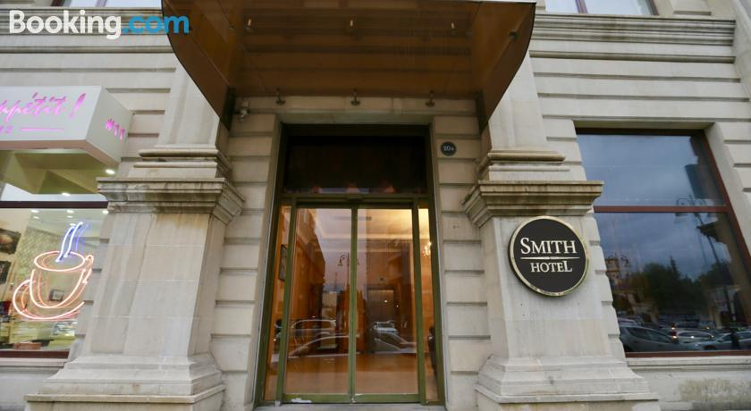
Smith Hotel Baku:

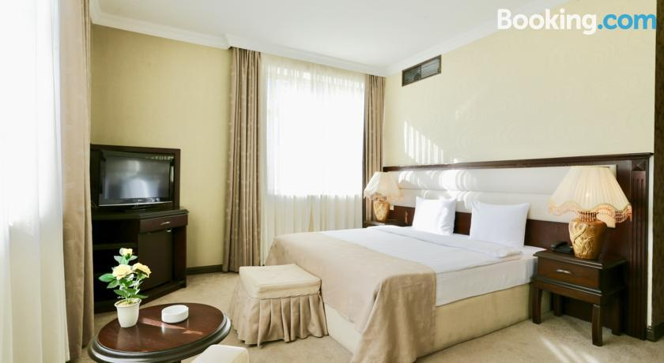

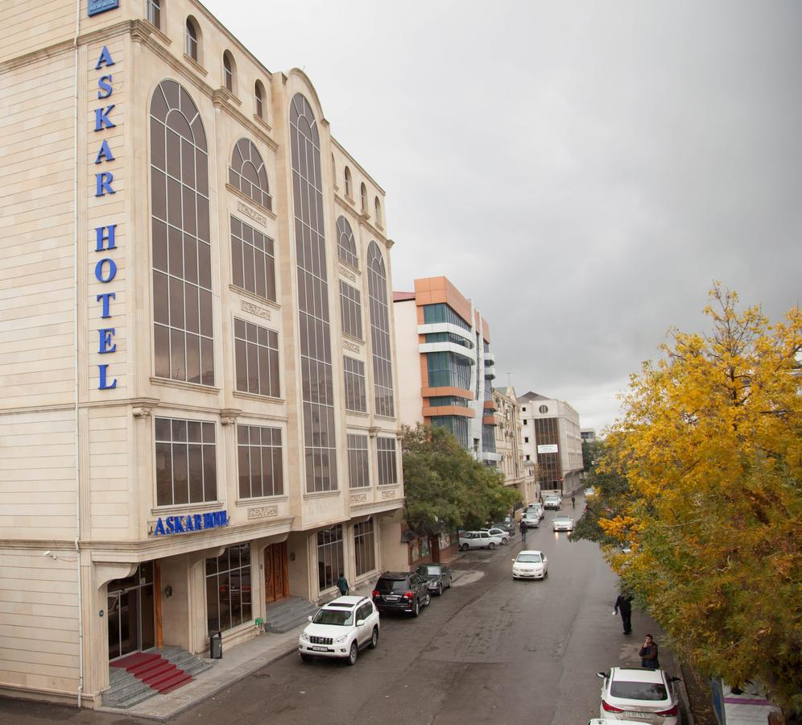
Askar Hotel Baku:
